Terraform task-5
- Execute the script shown in the video.
Terraform Remote state and state locking:

What is Terraform State?
Terraform uses a state file to keep track of the infrastructure it manages.

What is Remote State?
Remote state means storing the Terraform state file in a remote/shared location instead of keeping it only on your local computer.
Instead of:
Your laptop
└── terraform.tfstate
you can use:
Your laptop
│
▼
Terraform
│
▼
S3
│
└── terraform.tfstate

What is State Locking?
State locking prevents multiple Terraform operations from modifying the same state at the same time.
For example, imagine:
Developer A
terraform apply
│
▼
S3 state
At exactly the same time:
Developer B
terraform apply
│
▼
S3 state
Both are trying to modify the same state.
This can cause conflicts or state corruption.
State locking solves this.

We can use s3 as remote backend and dynamo db for state locking.
First creating bucket
terraform {
required_providers {
aws = {
source = "hashicorp/aws"
}
}
}

provider "aws" {
region = "us-east-1"
}

resource "aws_s3_bucket" "s3_bucket" {
bucket = "terraform-practice-0549-2026"
}
Terraform init
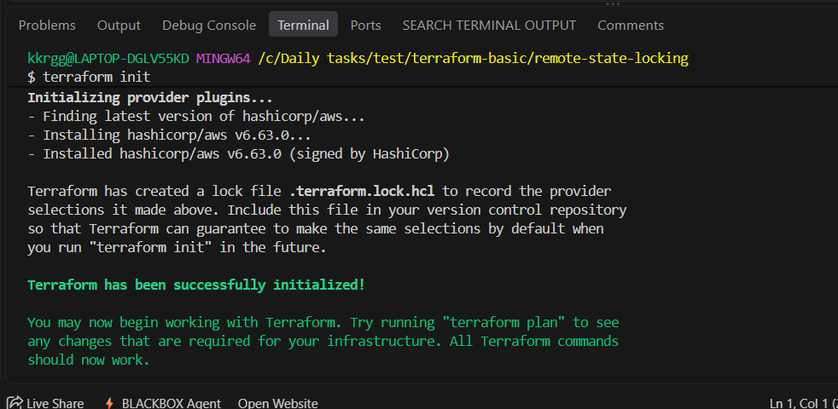
Terraform plan
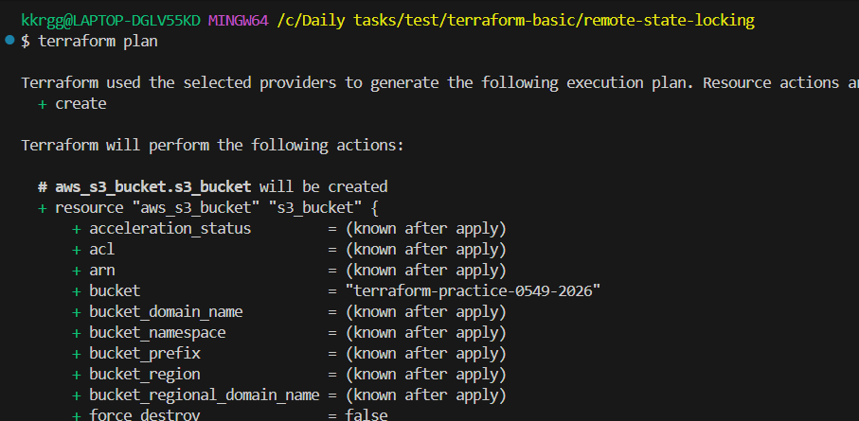
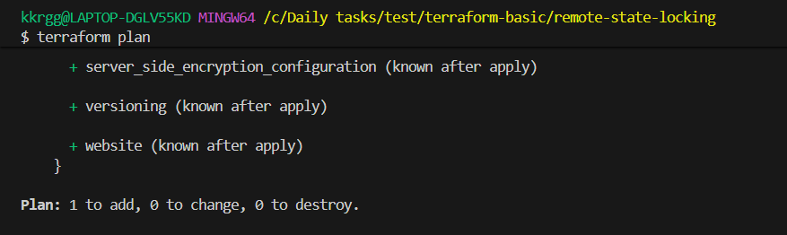
Terraform apply
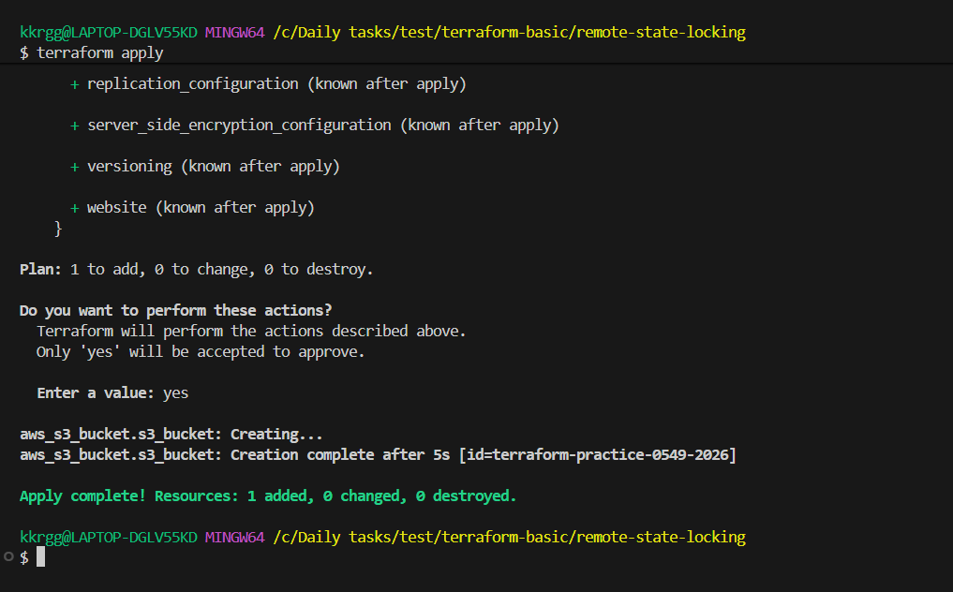
Goto Aws console open s3 service and check for bucket that is created.
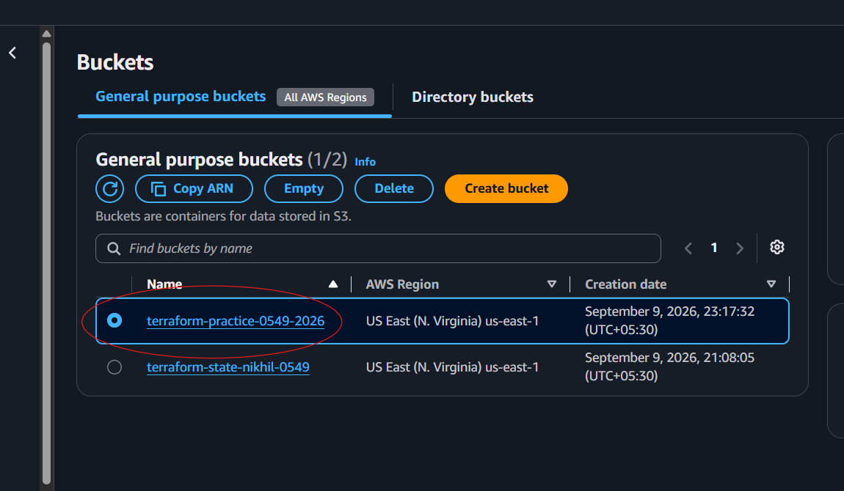
Create dynamo db using terraform:
resource "aws_dynamodb_table" "dynamodb-terraform-state-lock" {
name = "terraform-state-lock-dynamo"
hash_key = "LockID"
read_capacity = 20
write_capacity = 20

attribute {
name = "LockID"
type = "S"
}
}
Main.tf
terraform {
required_providers {
aws = {
source = "hashicorp/aws"
}
}
}

provider "aws" {
region = "us-east-1"
}

resource "aws_s3_bucket" "s3_bucket" {
bucket = "terraform-practice-0549-2026"
}
resource "aws_dynamodb_table" "dynamodb-terraform-state-lock" {
name = "terraform-state-lock-dynamo"
hash_key = "LockID"
read_capacity = 20
write_capacity = 20

attribute {
name = "LockID"
type = "S"
}
}

Terraform init
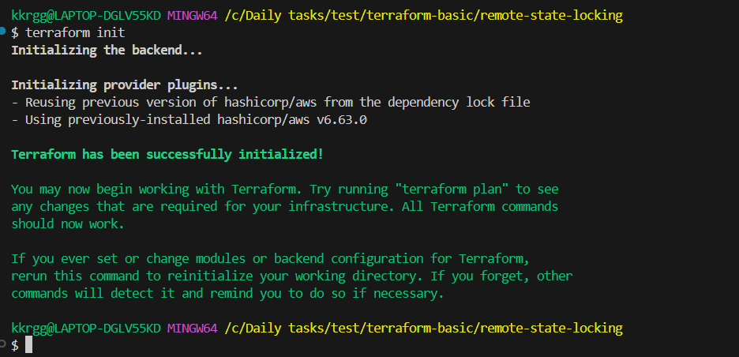
Terraform apply
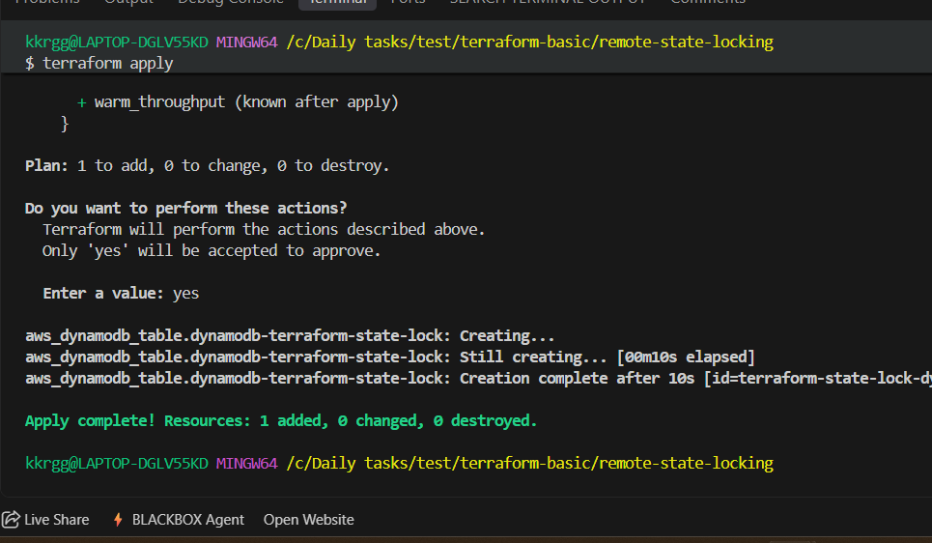
Goto Aws console open DynamoDB service and check.
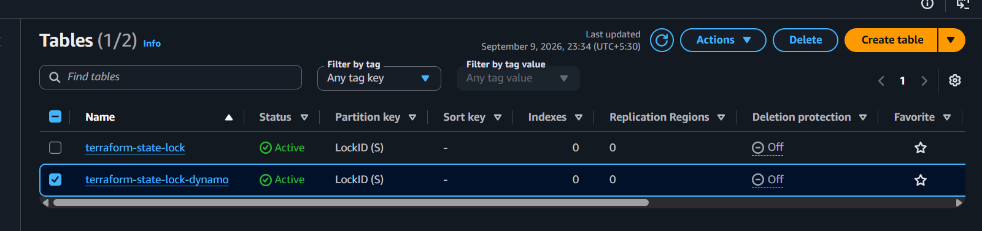
S3 as backend for terraform.tfstate file:
terraform {
backend "s3" {
bucket = "bucket-name"
dynamodb_table = "terraform-state-lock-dynamo"
key = "terraform.tfstate"
region = "us-east-1"
}
}

Main.tf
terraform {
required_providers {
aws = {
source = "hashicorp/aws"
}
}
}

provider "aws" {
region = "us-east-1"
}

resource "aws_s3_bucket" "s3_bucket" {
bucket = "terraform-practice-0549-2026"
}
resource "aws_dynamodb_table" "dynamodb-terraform-state-lock" {
name = "terraform-state-lock-dynamo"
hash_key = "LockID"
read_capacity = 20
write_capacity = 20

attribute {
name = "LockID"
type = "S"
}
}
terraform {
backend "s3" {
bucket = "terraform-practice-0549-2026"
dynamodb_table = "terraform-state-lock-dynamo"
key = "terraform.tfstate"
region = "us-east-1"
}
}

Terraform init
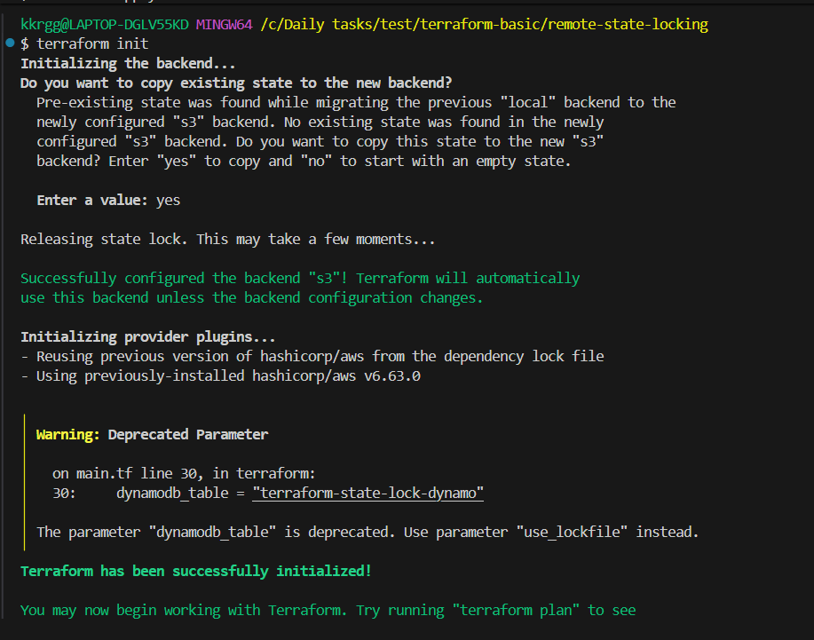
Terraform apply
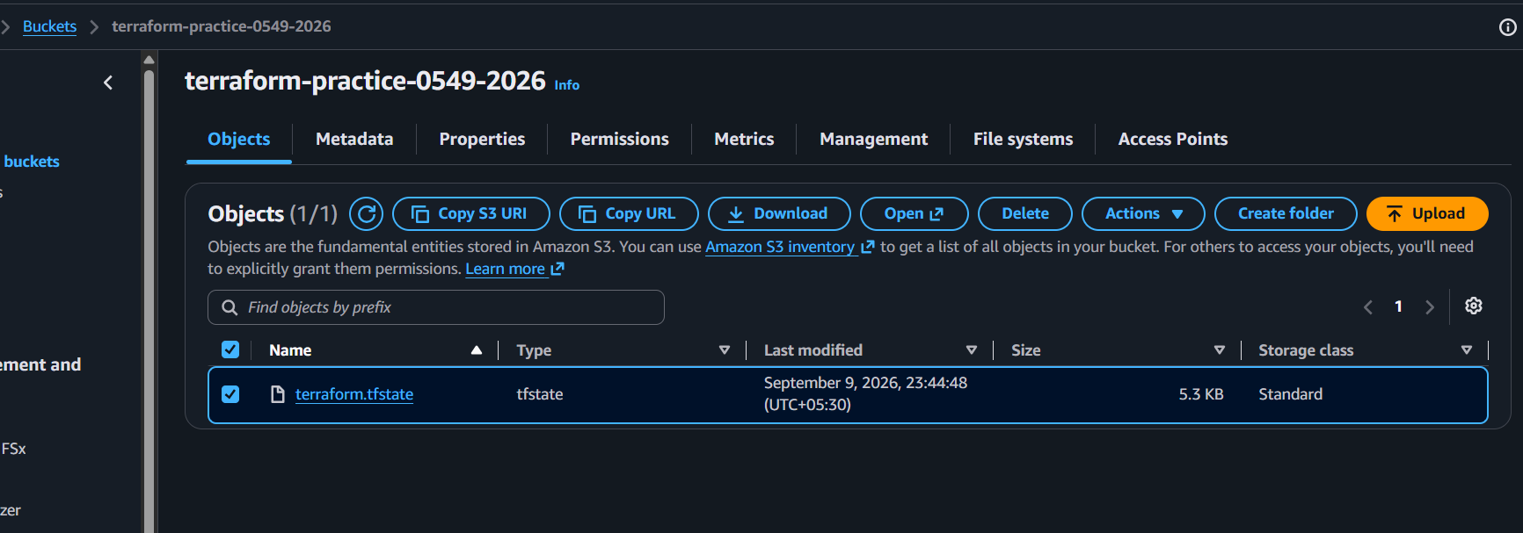

Terraform Provisioners:
Terraform provisioners allow us to execute command,scripts on remote machines or
local place were terraform is installed.

Provisioners will be written inside the reource blocks.

We have two types of provisioners

1) Remote provisioner
This is used to execute commands at the run time on remote machines.
2) Local provisioner
This is used to execute commands at the run time on local machine.

- Create one EC2 instance with httpd installed using a Terraform script.

Objective
The objective of this task is to use Terraform Infrastructure as Code (IaC) to:
- Create an EC2 instance in AWS.
- Install the Apache HTTPD web server automatically using Terraform's user_data.
- Start and enable the HTTPD service.
- Create a simple web page.
- Verify that the web server is running on the EC2 instance.

📁 Project Structure
Create a folder in VS Code:
terraform-ec2-httpd/
├── main.tf
└── user_data.sh

1. main.tf
provider "aws" {
region = "us-east-1"
}

resource "aws_security_group" "httpd_sg" {
name = "terraform-httpd-sg"
description = "Allow HTTP traffic"

ingress {
description = "HTTP"
from_port = 80
to_port = 80
protocol = "tcp"
cidr_blocks = ["0.0.0.0/0"]
}

egress {
from_port = 0
to_port = 0
protocol = "-1"
cidr_blocks = ["0.0.0.0/0"]
}

tags = {
Name = "Terraform-HTTPD-SG"
}
}

resource "aws_instance" "web_server" {
ami = "ami-0c101f26f147fa7fd"
instance_type = "t3.micro"

vpc_security_group_ids = [aws_security_group.httpd_sg.id]

user_data = file("user_data.sh")

tags = {
Name = "Terraform-HTTPD-Server"
}
}

output "public_ip" {
value = aws_instance.web_server.public_ip
}

2. user_data.sh
#!/bin/bash

dnf update -y
dnf install -y httpd

systemctl start httpd
systemctl enable httpd

echo "Hello from Terraform EC2" > /var/www/html/index.html

3. Configure AWS
Since we are working from VS Code with AWS CLI configured, verify:
aws sts get-caller-identity
You should see your AWS account/user information.
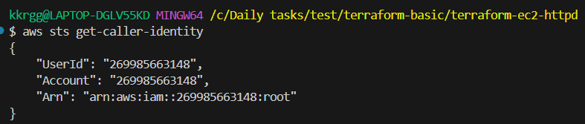

4. Initialize Terraform
Inside the project directory:
terraform init
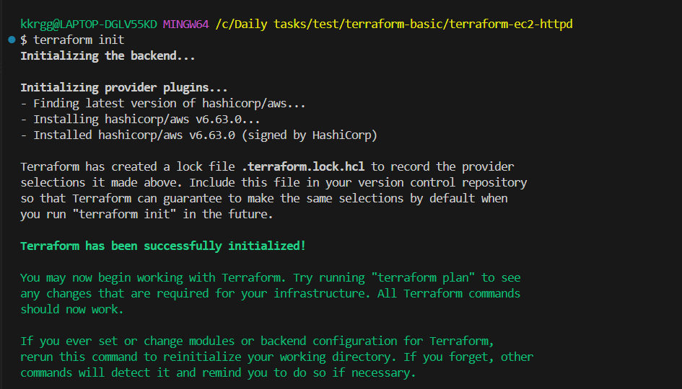
Expected:
Terraform has been successfully initialized!

5. Validate
terraform validate
Expected:
Success! The configuration is valid.
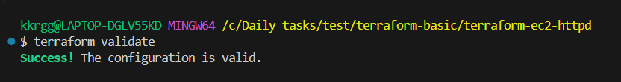

6. Plan
terraform plan
You should see approximately:
Plan: 1 to add, 0 to change, 0 to destroy.
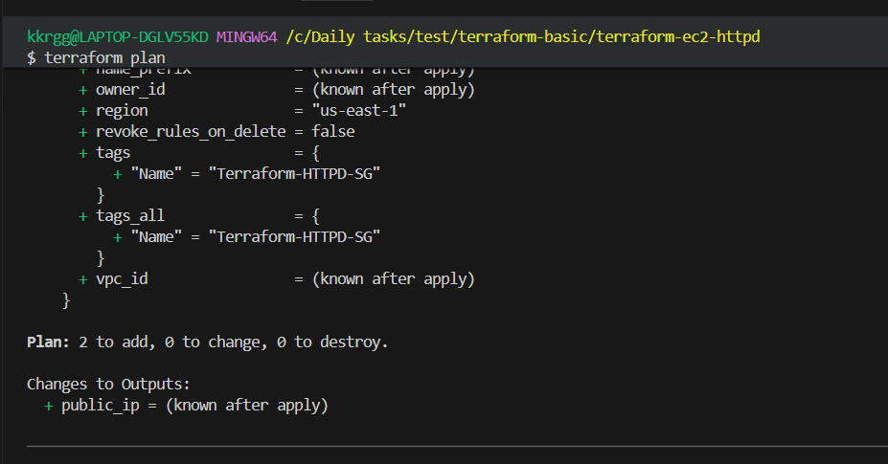

7. Create the EC2 instance
terraform apply
Type:
yes
Terraform should create:
aws_instance.web_server
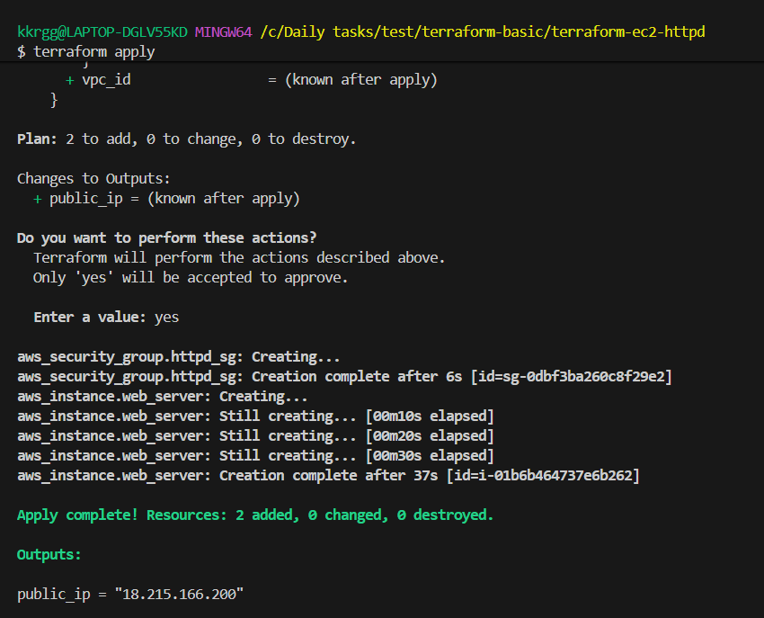

8. Verify the EC2 instance
Go to:
AWS Console → EC2 → Instances
You should see:
Name: Terraform-HTTPD-Server
State: Running
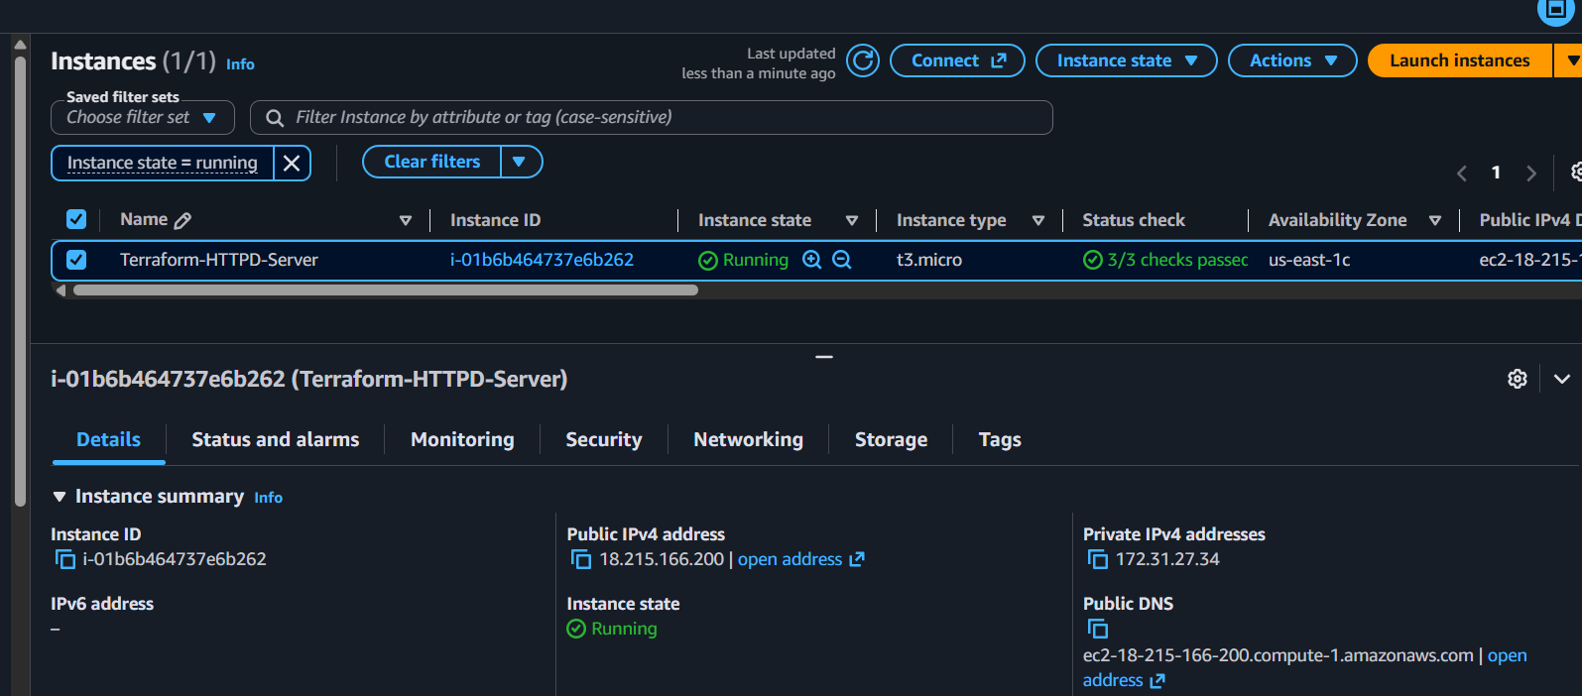

Copy the IP and open:
http://<PUBLIC-IP>
You should see:
Hello from Terraform EC2

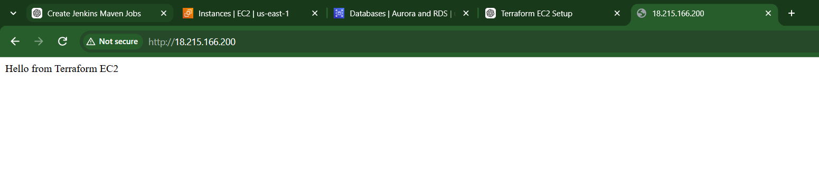
- Set up S3 as backend for task 2.

Objective
Configure Amazon S3 as the remote backend for the Terraform project from Task 2.

Expected Outcome
Before Task 3:
VS Code
│
└── terraform.tfstate
│
└── EC2 instance
After Task 3:
VS Code
│
└── Terraform
│
└── S3 Bucket
│
└── terraform.tfstate
│
└── EC2 instance

Step 1 — Create an S3 bucket
We'll create the S3 bucket separately first.
Add this to your existing main.tf:
resource "aws_s3_bucket" "terraform_state" {
bucket = "terraform-state-nikhil-0549"

tags = {
Name = "Terraform State Bucket"
Environment = "Dev"
}
}

Main.tf

provider "aws" {
region = "us-east-1"
}

resource "aws_security_group" "httpd_sg" {
name = "terraform-httpd-sg"
description = "Allow HTTP traffic"

ingress {
description = "HTTP"
from_port = 80
to_port = 80
protocol = "tcp"
cidr_blocks = ["0.0.0.0/0"]
}

egress {
from_port = 0
to_port = 0
protocol = "-1"
cidr_blocks = ["0.0.0.0/0"]
}

tags = {
Name = "Terraform-HTTPD-SG"
}
}

resource "aws_instance" "web_server" {
ami = "ami-0c101f26f147fa7fd"
instance_type = "t3.micro"

vpc_security_group_ids = [aws_security_group.httpd_sg.id]

user_data = file("user_data.sh")

tags = {
Name = "Terraform-HTTPD-Server"
}
}

output "public_ip" {
value = aws_instance.web_server.public_ip
}
resource "aws_s3_bucket" "terraform_state" {
bucket = "terraform-state-nikhil-0549"

tags = {
Name = "Terraform State Bucket"
Environment = "Dev"
}
}

Important
S3 bucket names must be globally unique.
If:
terraform-state-nikhil-0549
is already taken, change it to something unique, for example:
terraform-state-nikhil-0549-2026

Step 2 — Create the bucket
Run:
terraform fmt
terraform validate

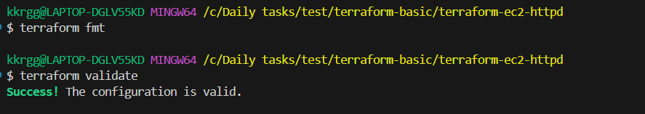

terraform plan

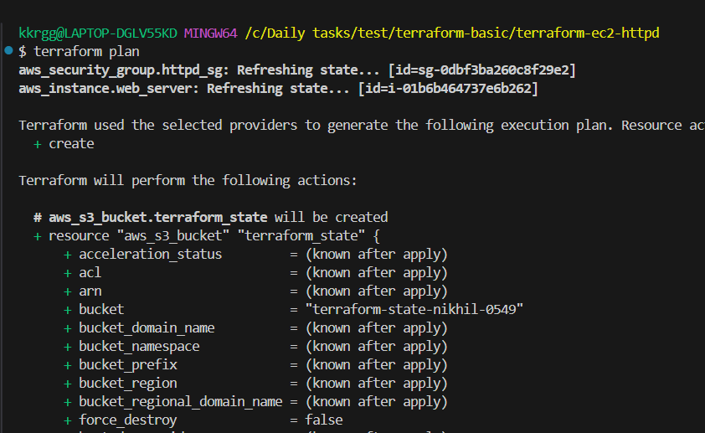

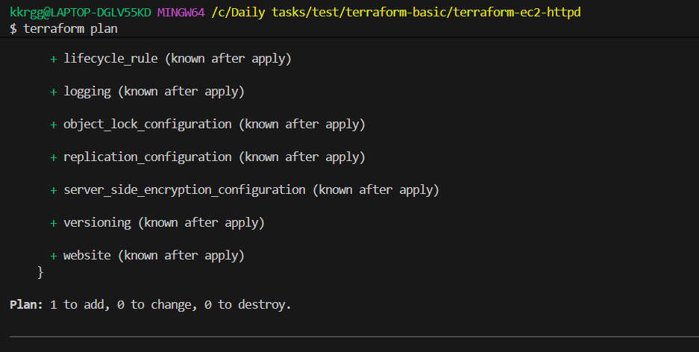
You should see approximately:
Plan: 1 to add, 0 to change, 0 to destroy.
Then:
terraform apply
Enter:
yes
You should get:
Apply complete! Resources: 1 added, 0 changed, 0 destroyed.
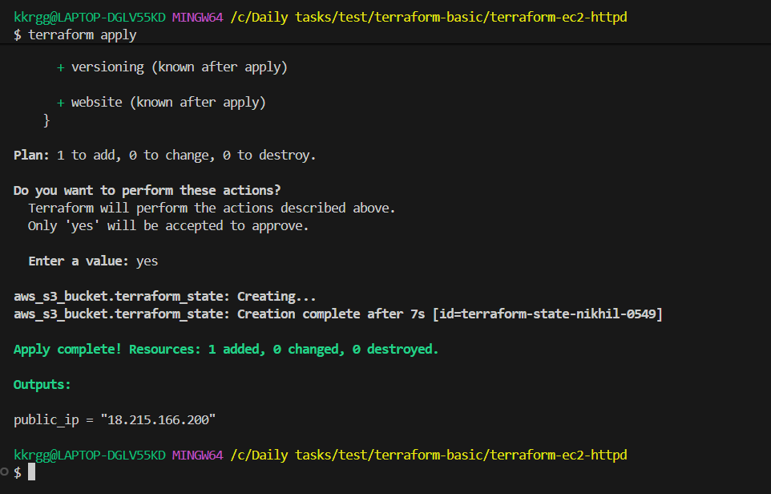

Verify in AWS
Go to:
AWS Console → S3
You should see your bucket.
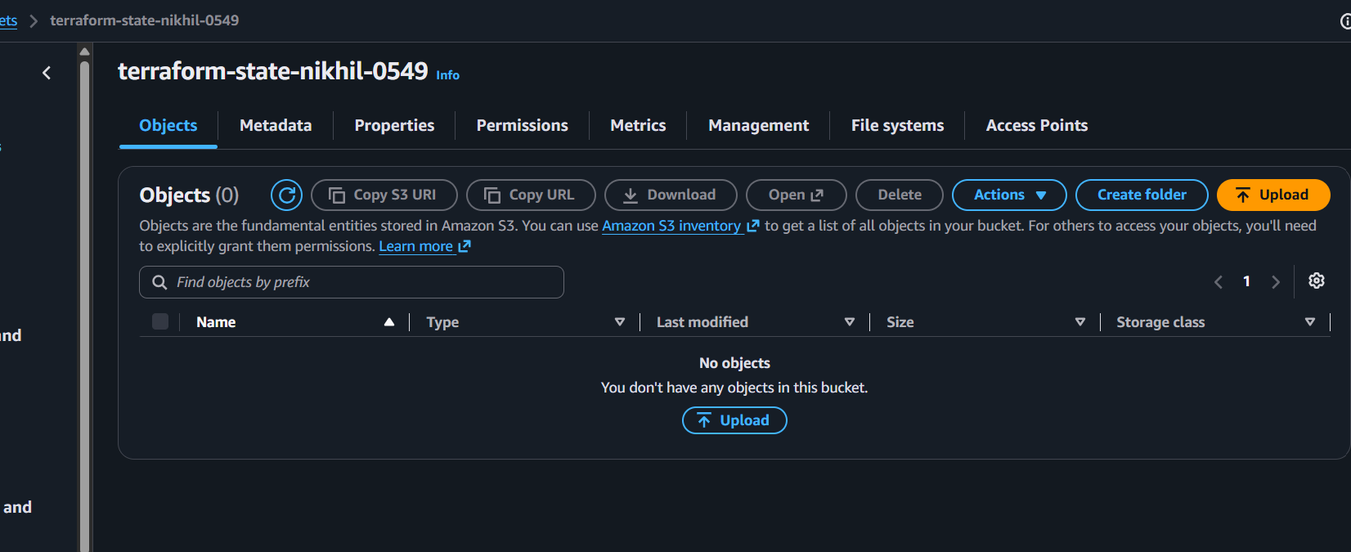

Step 3 — Configure S3 Backend
Now add the backend configuration to main.tf.
At the top of the file, after the provider or before resources, add:
terraform {
backend "s3" {
bucket = "terraform-state-nikhil-0549"
key = "ec2-httpd/terraform.tfstate"
region = "us-east-1"
}
}
So the beginning of your main.tf will look like:
provider "aws" {
region = "us-east-1"
}

terraform {
backend "s3" {
bucket = "terraform-state-nikhil-0549"
key = "ec2-httpd/terraform.tfstate"
region = "us-east-1"
}
}

Main.tf

provider "aws" {
region = "us-east-1"
}
terraform {
backend "s3" {
bucket = "terraform-state-nikhil-0549"
key = "ec2-httpd/terraform.tfstate"
region = "us-east-1"
}
}
resource "aws_security_group" "httpd_sg" {
name = "terraform-httpd-sg"
description = "Allow HTTP traffic"

ingress {
description = "HTTP"
from_port = 80
to_port = 80
protocol = "tcp"
cidr_blocks = ["0.0.0.0/0"]
}

egress {
from_port = 0
to_port = 0
protocol = "-1"
cidr_blocks = ["0.0.0.0/0"]
}

tags = {
Name = "Terraform-HTTPD-SG"
}
}

resource "aws_instance" "web_server" {
ami = "ami-0c101f26f147fa7fd"
instance_type = "t3.micro"

vpc_security_group_ids = [aws_security_group.httpd_sg.id]

user_data = file("user_data.sh")

tags = {
Name = "Terraform-HTTPD-Server"
}
}

output "public_ip" {
value = aws_instance.web_server.public_ip
}
resource "aws_s3_bucket" "terraform_state" {
bucket = "terraform-state-nikhil-0549"

tags = {
Name = "Terraform State Bucket"
Environment = "Dev"
}
}

Step 4 — Reinitialize Terraform
Now run:
terraform init
Terraform will detect that you're changing from the local backend to the S3 backend.
You should see a message similar to:
Successfully configured the backend "s3"!
Terraform may ask:
Do you want to copy existing state to the new backend?
Answer:
yes
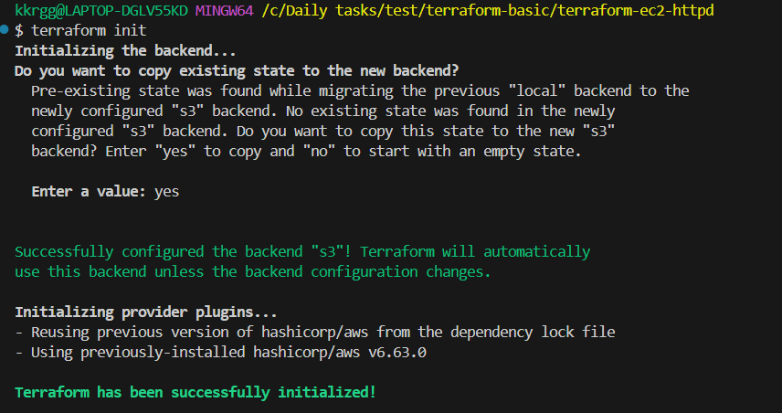

Step 5 — Verify the migration
Run:
terraform plan
The most important expected result is:
No changes. Your infrastructure matches the configuration.
Or:
Plan: 0 to add, 0 to change, 0 to destroy.
That confirms Terraform still knows about your existing EC2 instance.
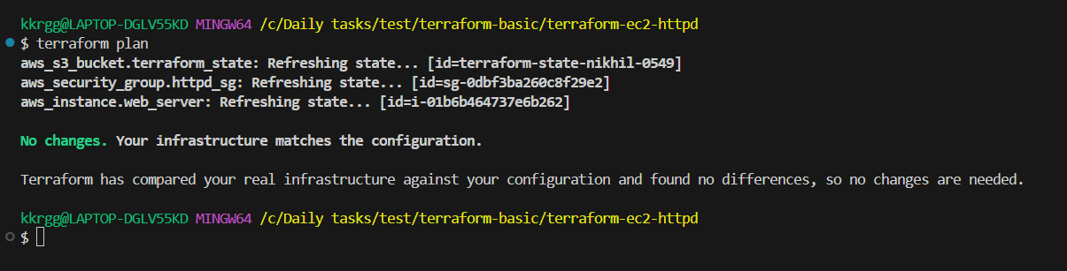

Step 6 — Verify the state in S3
Go to:
AWS Console → S3 → Your bucket
You should find:
ec2-httpd/
terraform.tfstate
So your state is now stored remotely.
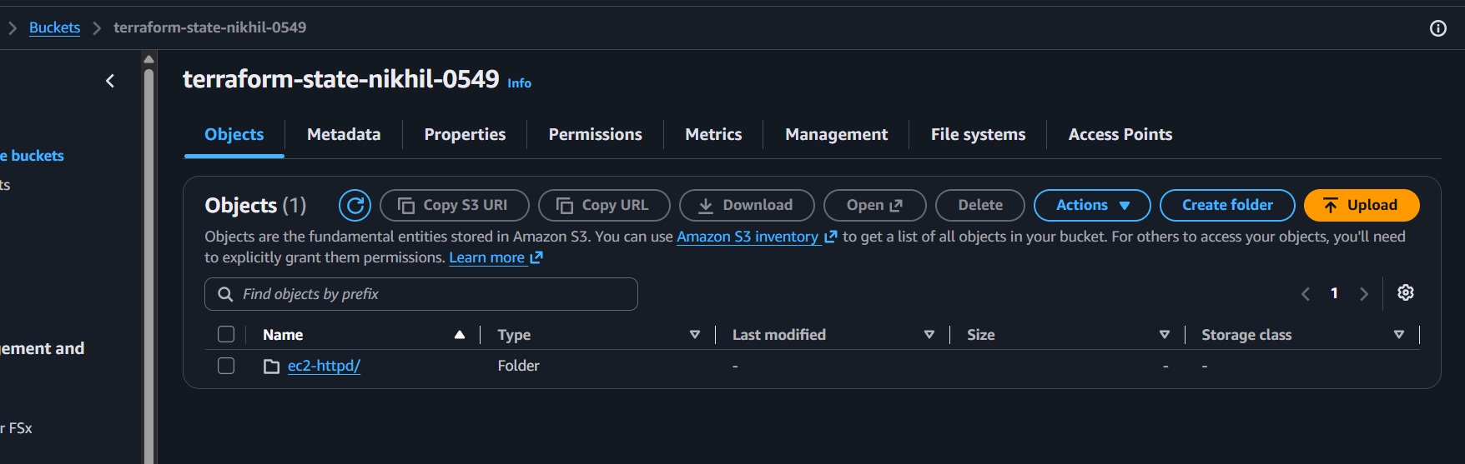
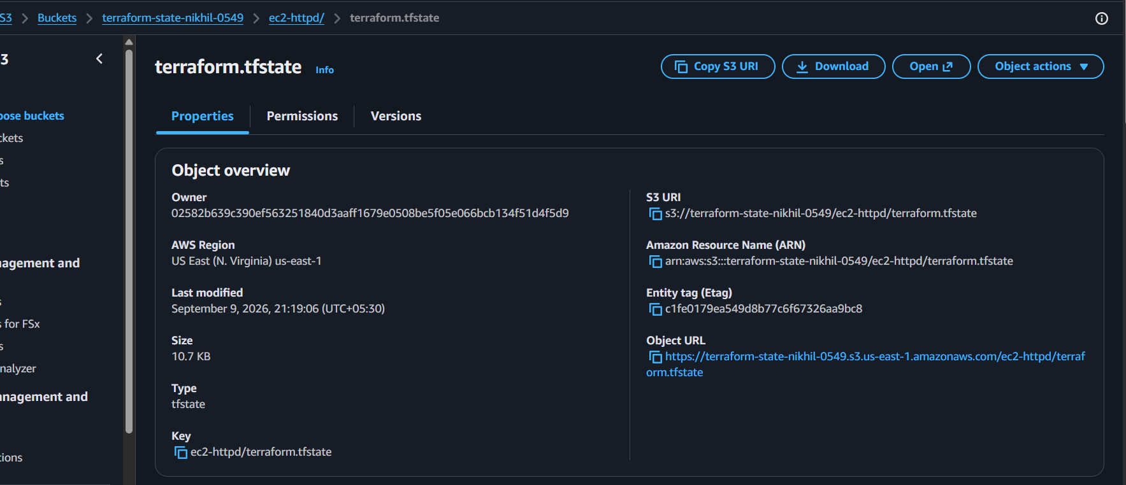

- Set up DynamoDB locking for task 2.

Objective
Configure DynamoDB state locking for the Terraform project so that Terraform prevents multiple users/processes from modifying the same Terraform state at the same time.

Step 1 — Create a DynamoDB table
Add this resource to your existing main.tf:
resource "aws_dynamodb_table" "terraform_lock" {
name = "terraform-state-lock"
billing_mode = "PAY_PER_REQUEST"
hash_key = "LockID"

attribute {
name = "LockID"
type = "S"
}

tags = {
Name = "Terraform State Lock"
}
}

Main.tf
provider "aws" {
region = "us-east-1"
}
terraform {
backend "s3" {
bucket = "terraform-state-nikhil-0549"
key = "ec2-httpd/terraform.tfstate"
region = "us-east-1"
}
}
resource "aws_security_group" "httpd_sg" {
name = "terraform-httpd-sg"
description = "Allow HTTP traffic"

ingress {
description = "HTTP"
from_port = 80
to_port = 80
protocol = "tcp"
cidr_blocks = ["0.0.0.0/0"]
}

egress {
from_port = 0
to_port = 0
protocol = "-1"
cidr_blocks = ["0.0.0.0/0"]
}

tags = {
Name = "Terraform-HTTPD-SG"
}
}

resource "aws_instance" "web_server" {
ami = "ami-0c101f26f147fa7fd"
instance_type = "t3.micro"

vpc_security_group_ids = [aws_security_group.httpd_sg.id]

user_data = file("user_data.sh")

tags = {
Name = "Terraform-HTTPD-Server"
}
}

output "public_ip" {
value = aws_instance.web_server.public_ip
}
resource "aws_s3_bucket" "terraform_state" {
bucket = "terraform-state-nikhil-0549"

tags = {
Name = "Terraform State Bucket"
Environment = "Dev"
}
}
resource "aws_dynamodb_table" "terraform_lock" {
name = "terraform-state-lock"
billing_mode = "PAY_PER_REQUEST"
hash_key = "LockID"

attribute {
name = "LockID"
type = "S"
}

tags = {
Name = "Terraform State Lock"
}
}

Our project now has:
main.tf
│
├── AWS provider
├── S3 backend
├── S3 bucket
├── DynamoDB table
└── EC2 instance

Step 2 — Add DynamoDB to the S3 backend
Change our existing backend:
terraform {
backend "s3" {
bucket = "terraform-state-nikhil-0549"
key = "ec2-httpd/terraform.tfstate"
region = "us-east-1"
dynamodb_table = "terraform-state-lock"
}
}
Use our actual S3 bucket name.
provider "aws" {
region = "us-east-1"
}
terraform {
backend "s3" {
bucket = "terraform-state-nikhil-0549"
key = "ec2-httpd/terraform.tfstate"
region = "us-east-1"
dynamodb_table = "terraform-state-lock"
}
}
resource "aws_security_group" "httpd_sg" {
name = "terraform-httpd-sg"
description = "Allow HTTP traffic"

ingress {
description = "HTTP"
from_port = 80
to_port = 80
protocol = "tcp"
cidr_blocks = ["0.0.0.0/0"]
}

egress {
from_port = 0
to_port = 0
protocol = "-1"
cidr_blocks = ["0.0.0.0/0"]
}

tags = {
Name = "Terraform-HTTPD-SG"
}
}

resource "aws_instance" "web_server" {
ami = "ami-0c101f26f147fa7fd"
instance_type = "t3.micro"

vpc_security_group_ids = [aws_security_group.httpd_sg.id]

user_data = file("user_data.sh")

tags = {
Name = "Terraform-HTTPD-Server"
}
}

output "public_ip" {
value = aws_instance.web_server.public_ip
}
resource "aws_s3_bucket" "terraform_state" {
bucket = "terraform-state-nikhil-0549"

tags = {
Name = "Terraform State Bucket"
Environment = "Dev"
}
}
resource "aws_dynamodb_table" "terraform_lock" {
name = "terraform-state-lock"
billing_mode = "PAY_PER_REQUEST"
hash_key = "LockID"

attribute {
name = "LockID"
type = "S"
}

tags = {
Name = "Terraform State Lock"
}
}

Step 3 — Important Terraform limitation
There is a dependency problem here:
Terraform
↓
S3 Backend
↓
DynamoDB Lock Table
Terraform backend configuration is initialized before Terraform manages normal resources.
Therefore, if the DynamoDB table is defined in the same configuration, Terraform cannot use that table for locking until the table already exists.

Create the DynamoDB table first
For this task, the easiest learning approach is to temporarily create the DynamoDB table using the AWS CLI:
aws dynamodb create-table \
--table-name terraform-state-lock \
--attribute-definitions AttributeName=LockID,AttributeType=S \
--key-schema AttributeName=LockID,KeyType=HASH \
--billing-mode PAY_PER_REQUEST \
--region us-east-1
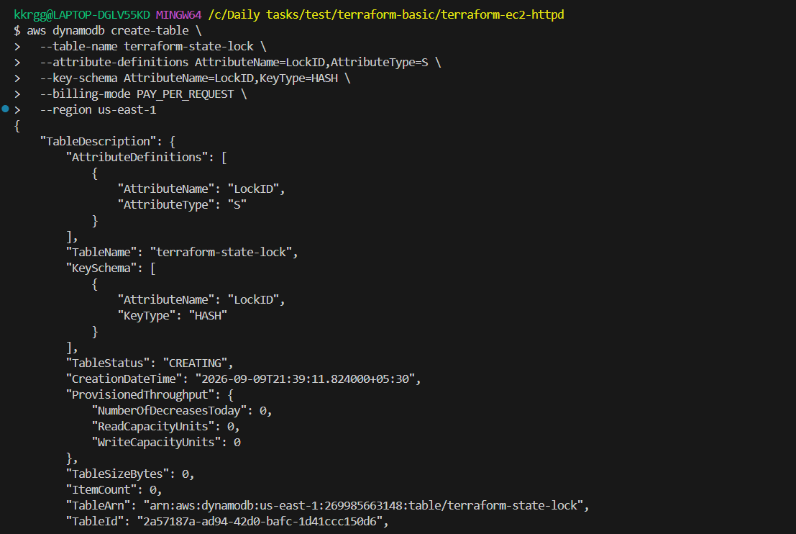
Then verify:
aws dynamodb describe-table \
--table-name terraform-state-lock \
--region us-east-1
You should see:
TableName: terraform-state-lock
TableStatus: ACTIVE
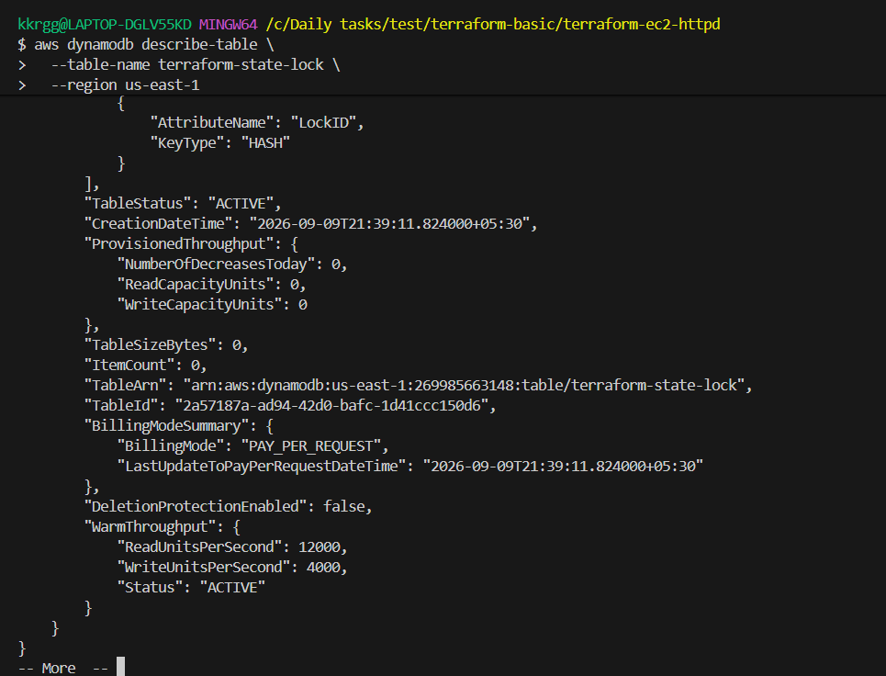

Step 4 — Configure the backend
Now make sure your backend contains:
terraform {
backend "s3" {
bucket = "terraform-state-nikhil-0549"
key = "ec2-httpd/terraform.tfstate"
region = "us-east-1"
dynamodb_table = "terraform-state-lock"
}
}
Then run:
terraform init -reconfigure
If Terraform asks about migrating state, choose:
Yes
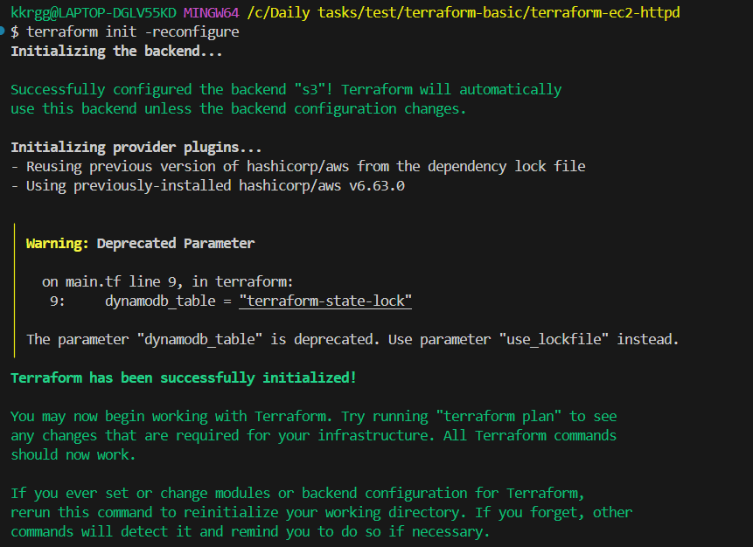

We should import the existing DynamoDB table into Terraform state.
Run:
terraform import aws_dynamodb_table.terraform_lock terraform-state-lock
You should get something like:
Import successful!

aws_dynamodb_table.terraform_lock: Import complete!
Then run:
terraform plan

Expected result
Ideally:
No changes. Your infrastructure matches the configuration.
or:
Plan: 0 to add, 0 to change, 0 to destroy.

Why import?
Currently:
AWS
└── DynamoDB
└── terraform-state-lock ✅ exists

Terraform State
└── DynamoDB table ❌ not tracked
After import:
AWS
└── DynamoDB
└── terraform-state-lock ✅

Terraform State
└── DynamoDB table ✅ tracked
So import does not create another table and does not destroy your existing infrastructure.

Step 5 — Verify Terraform
Run:
terraform plan
You want:
No changes
or:
Plan: 0 to add, 0 to change, 0 to destroy.
This is important because we don't want this Task to recreate our EC2 instance.
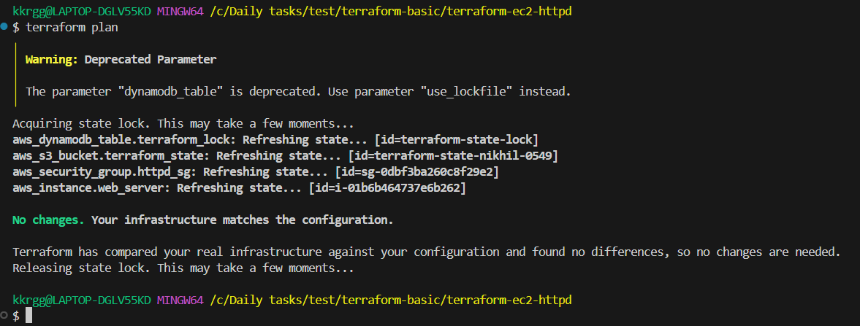

Step 6 — Verify DynamoDB
AWS Console:
AWS Console → DynamoDB → Tables
You should see:
terraform-state-lock
Its key should be:
LockID
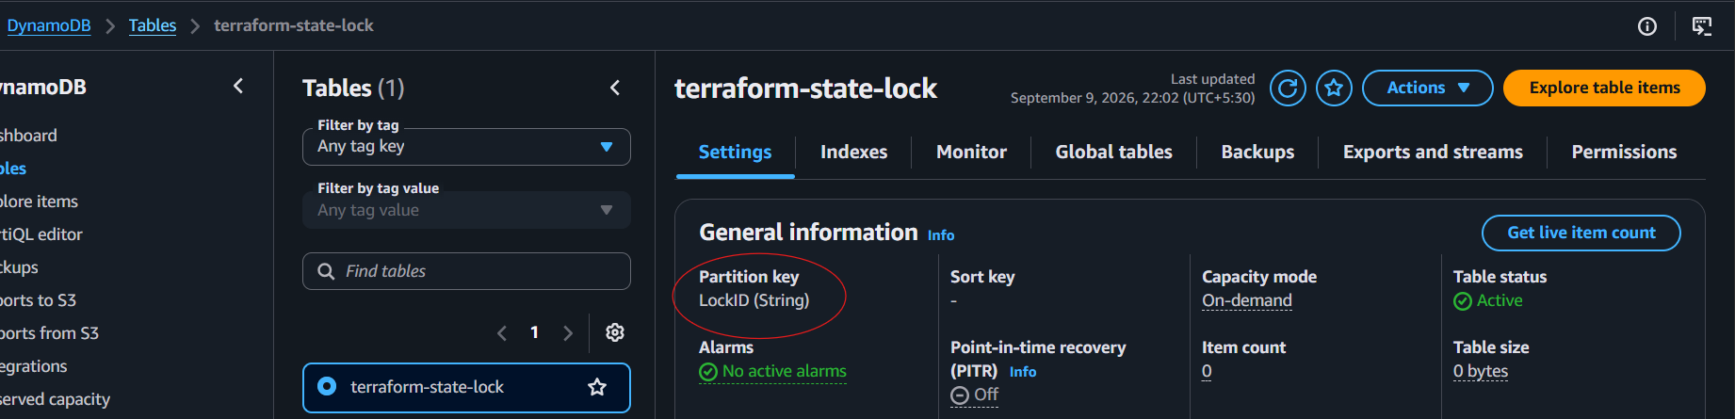

🔐 How locking works
Suppose you and another engineer run Terraform at the same time.
Without locking:
User A ──→ terraform apply ──→ state
User B ──→ terraform apply ──→ state
↑
Conflict possible
With DynamoDB locking:
User A ──→ Terraform ──→ DynamoDB
│
│ Lock acquired
↓
S3 state

User B ──→ Terraform ──→ DynamoDB
│
└── Lock exists
↓
Wait / fail
The DynamoDB table uses:
LockID
as its partition key.
Terraform creates a lock record while it is performing a state-changing operation and removes it when the operation finishes.

After completing Task 4:
Terraform
│
┌─────────┴─────────┐
↓ ↓
Amazon S3 DynamoDB
│ │
│ └── State Lock
↓
terraform.tfstate
│
↓
EC2 + HTTPD

